GROUP THEATRE (1931-1941)

Founded in 1931 by Harold Clurman, Cheryl Crawford, and Lee Strasberg, the Group Theatre was conceived as a company dedicated to staging socially relevant plays, with a permanent ensemble of actors trained in a new, shared technique. Its legacy can be located in the contributions it made to modern American drama, particularly through the works of member-playwright Clifford Odets, and through its practise of the Stanislavsky System, which revolutionized American acting, developing into a psychologically realistic approach widely known as ‘the Method’.

The Group had no manifesto, but Clurman articulated the founders’ shared vision in fervent oratory. Damning the commercialism, poor material, and inadequate acting of the moment, Clurman declared ‘America has as yet no Theatre’ (qtd. in Smith, 4), and he talked young artists into creating one. Unity of production was a key goal, with all elements—acting, directing, writing, and design—creating a coherent, meaningful whole. The Group’s modernist influences were many; Clurman and Strasberg were widely read, inspired by artists like Jacques Copeau and Edward Gordon Craig, and most powerfully influenced by Konstantin Stanislavsky and the Moscow Art Theatre, whose work they had seen onstage, and whose theories they studied at the American Laboratory Theatre.

With actor training a chief priority, the ensemble spent summers in the country, experimenting with exercises and improvisations while rehearsing plays. Paul Green’s The House of Connelly (1931) marked their Broadway debut; they also staged works by John Howard Lawson and Maxwell Anderson, among others. Sidney Kingsley’s Men in White (1933) was an early success, widely praised for its realistic portrayal of doctors against Mordecai Gorelick’s abstract hospital setting.

The Group’s mission reached its apotheosis in 1935, when it began to stage Odets’s plays. Most members were political progressives who lived and worked together, sharing meals as well as ideals, and the collective found its voice in Odets. Waiting for Lefty, set at a taxi drivers’ union meeting, unfolds in episodes in which characters enact their struggles in the depths of the Great Depression. The play’s final, climactic moment legendarily brought the audience to its feet, crying, ‘Strike!’, and the Group’s medium and message became one. Odets’s other Group plays include Awake and Sing (1935), Paradise Lost (1935), and Golden Boy (1937). He captured the lives of the lower middle class, and of Jewish families in New York in the 1930s; embracing leftist politics, he brought new subjects and structures to modern American drama.

Economic pressures and internal disputes led to the Group’s 1941 demise, but its influence continued through its individual members. Notable names include teachers Stella Adler, Bobby Lewis, Sanford Meisner, and Lee Strasberg; actors Lee J. Cobb and Karl Malden; and director Elia Kazan. The Group Theatre emblematized the spirit and struggle of the thirties, and ushered in a new era of American drama on stage and screen, performed by a new kind of actor.

References and Further Reading

Chinoy, Helen Krich. (1976) Reunion: A Self-Portrait of the Group Theatre, reprinted from Educational Theatre Journal, 28 (4) (December): 443-552.

----- (2013) The Group Theatre: Passion, Politics, and Performance in the Depression Era, ed. Don B. Wilmeth and Milly S. Barranger, New York: Palgrave Macmillan.

Clurman, Harold. (1945) The Fervent Years: The Story of the Group Theatre and the Thirties, New York: Alfred A. Knopf.

Odets, Clifford. (1939) Six Plays of Clifford Odets, New York: Modern Library.

Smith, Wendy. (1990) Real Life Drama: The Group Theatre and America, 1931-1940, New York: Grove Weidenfeld.

Strasberg, Lee. (1987) A Dream of Passion: The Development of the Method, Boston: Little, Brown and Co.

Rose Malague, University of Pennsylvania

Recommended Illustrations

[NOTE: Please use all four images for this important company if possible. If not, please prioritize as follows: 1) Elia Kazan in Waiting for Lefty; 2) Poster for Awake and Sing; 3) Production photo of Men in White; photo of Group Theatre founders.]

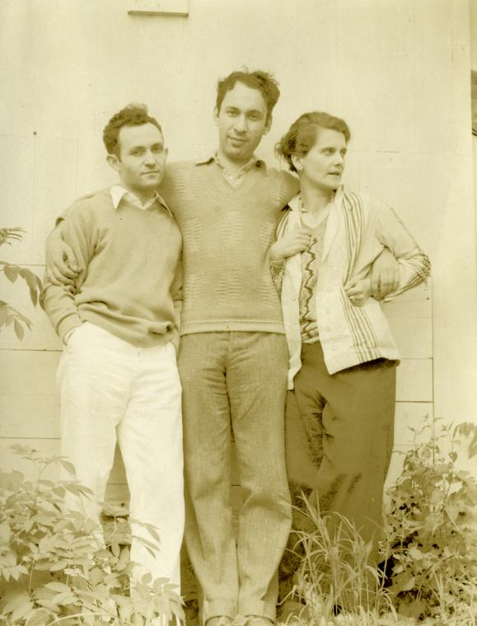

Group Theatre founders Lee Strasberg, Harold Clurman, and Cheryl Crawford, Brookfield Center, Connecticut, 1931.

[Source: New York Public Library. Online order form at nypl.org/permissions. Please paste the following information into the online order form:
Image ID: ps_the_2691
Title: Lee Strasberg, Harold Clurman, and Cheryl Crawford, Brookfield Center.
Photographer: No Credit
Please contact permissions@nypl.org or 212-930-0091 w/ any ordering questions. ]

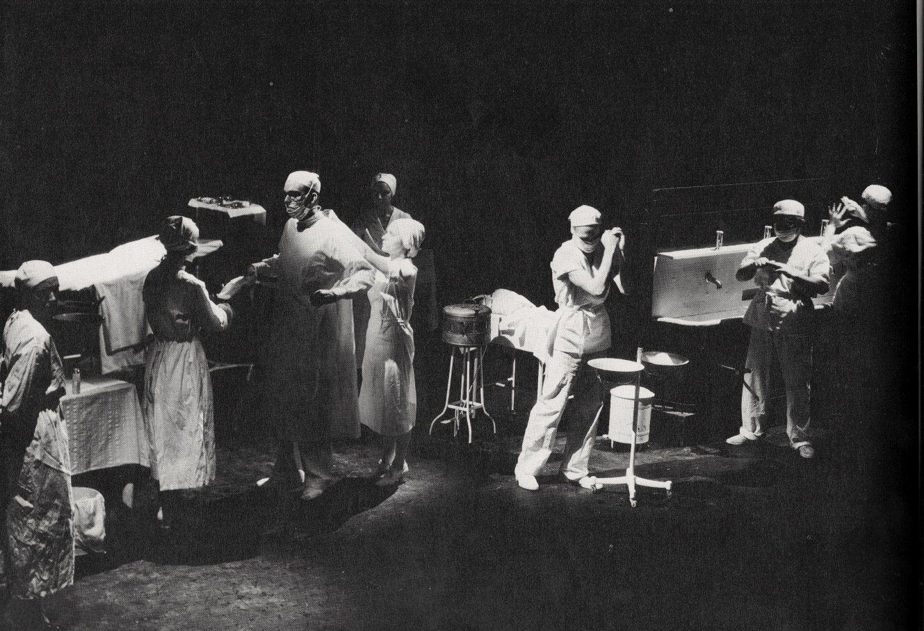

The Group Theatre’s production of Sidney Kingsley’s Men in White, 1933.
[Source: New York Public Library. Online order form at nypl.org/permissions. Please paste the following information into the online order form:
Image ID: 1607291
Title: Scene from the stage production Men in White.
Photographer: Vandamm.
Please contact permissions@nypl.org or 212-930-0091 w/ any ordering questions. ]

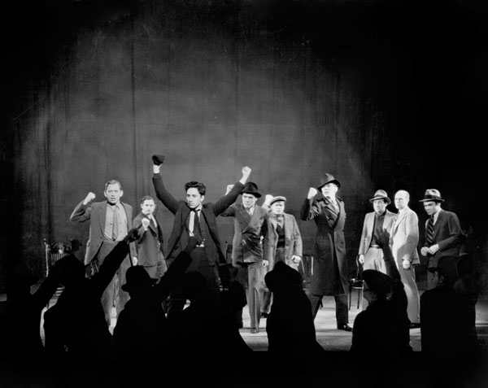

Elia Kazan in the Group Theatre production of Clifford Odets’s Waiting for Lefty, 1935.
[Source: New York Public Library. Online order form at nypl.org/permissions. Please paste the following information into the online order form:
Image ID: psnypl_the_4323
Title: Scene from the stage production Waiting for Lefty
Photographer: Vandamm. Please contact permissions@nypl.org or 212-930-0091 w/ any ordering questions. ]

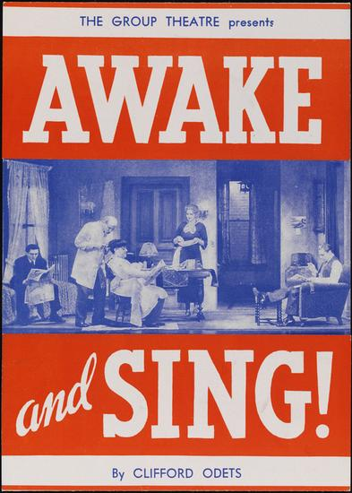

Poster for the Group Theatre’s production of Awake and Sing! by Clifford Odets, 1935.
[Source: Museum of New York, available at: http://collections.mcny.org/C.aspx?VP3=SearchResult_VPage&VBID=24UAYWPXZMU8&SMLS=1&RW=1425&RH=724 ]

